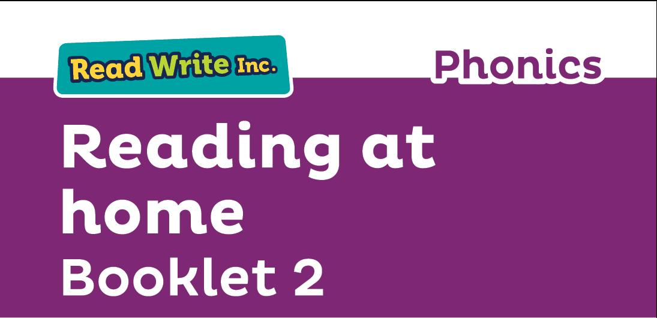
N

Glossary
Fred Talk – sounding out the word before reading (blending)

sound-blending – putting sounds together to make a word,
e.g. c–a–t cat

special friends – sounds written with more than one letter,
  - sh, ng, qu, ch

Speed Sounds – the individual sounds that make up words

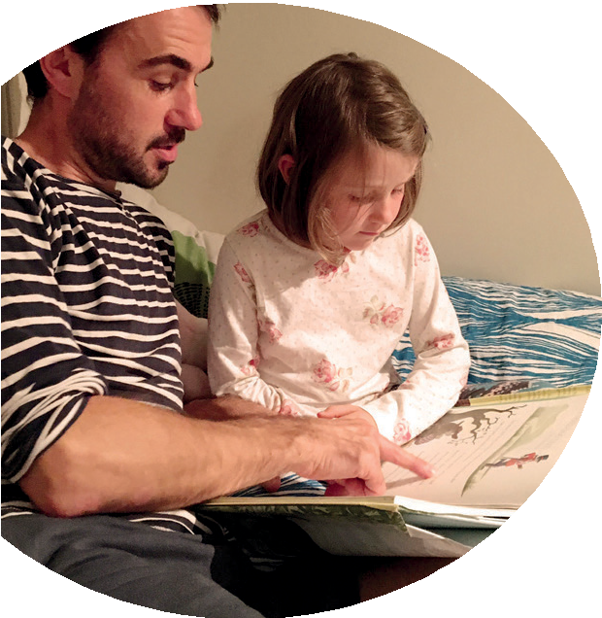
Read stories to your child with feeling! The more you love the story, the more your child will love reading.

Booklet 2 shows you how to help your child practice reading:
- Sets 2 and 3 Speed Sounds
- Green, Pink, Orange, Yellow, Blue and Grey Storybooks.

Your child is learning to read with Read Write Inc. Phonics, a very popular and successful literacy programme. This booklet shows you how you can get your child off to a quick start.

Your child will learn to read in a very simple way. He or she will learn to:
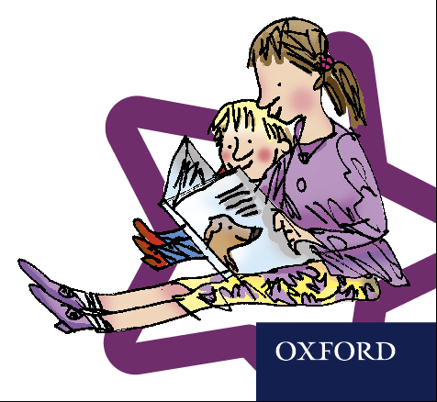
- Read letters by their ‘sounds’

Blend these sounds into words
- Read the words in a story.

www.ruthmiskin.com/parents has many videos to help you help your child.
For more information on Read Write Inc., please talk to the Read Write Inc. manager in your child’s school or visit www.readwriteinc.com.

8

How to listen to your child read
How will my child learn to read?

Your child will already have learnt to read:
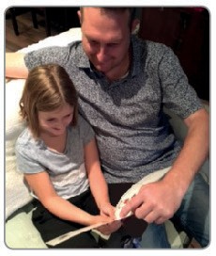

- Set 1 Speed Sounds: these are sounds written with one letter:
m a s d t i n p g o c k u b f e l h r j v
y w z x and sounds written with two letters • (your child will call these ‘special friends’): sh th ch
qu ng nk ck
- Words containing these sounds, by sound-blending,
e.g. m–a–t mat, c–a–t cat, g–o–t got, f–i–sh ﬁsh,
s–p–o–t spot, b–e–s–t best, s–p–l–a–sh splash
- They will have also read books containing these sounds.

When your child reads their RWI book bag book or RWI storybook:
- Do not read the book aloud before your child reads it to you.
- When your child reads the story, ask him or her to sound out the words that he or she can’t read automatically. Don’t allow your child to struggle too much. Praise your child when he or she succeeds.
- Read back each sentence or page to keep the plot moving. (Your child’s energy is going into reading the words not the story.)
- Do not ask your child to guess the word by using the pictures.
- Do it all with patience and love!
Now, he or she will learn to read:
- Set 2 Speed Sounds: ay ee igh ow oo oo ar or air ir ou oy
- Words containing these sounds
- Pink, Orange and Yellow Storybooks.
- Set 3 Speed Sounds: ea oi a-e i-e o-e u-e aw are ur er ow ai oa ew ire ear ure
- Words containing these sounds
- Blue and Grey Storybooks.

We have a storytime every day at school so children develop
a love of stories. The children will take home a high quality picture book to share with you at home which will also support this. These books may be above your child’s reading level, if so you could read it to them asking them questions about the story as you go.
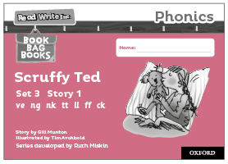
RWI eReader and RWI Storybooks You can access a copy of the story book your child has read at school via Oxford Owl (this is different to ebuddy we have used previously). Your child’s login details can be found in their reading journal.
Your child will have read this story three times, so should be able to read the story conﬁdently.
A brief explanation of how to follow the activities is included in the books.

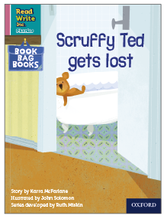
Book Bag Books
Your child will also bring home a Book Bag Book. This book builds upon the ideas and many of the words in the Storybook he or she has just read. Your child will need more support in reading this book.
Again, explanations of how to use the activities are included in the books.

1. How your child learns to read the Sets 2 and 3 Speed Sounds
Each sound has a picture and phrase to help your child remember the sound. For example:
- the sound ‘ay’ has the phrase ‘May I play?’ with a picture of children playing together
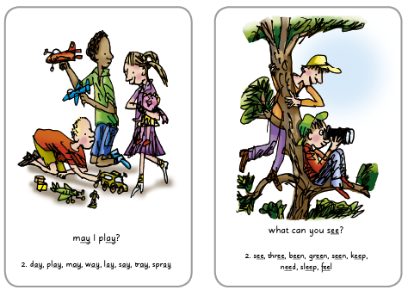
- the sound ‘ee’ has the phrase ‘What can you see?’ with a picture of two boys in a tree.

