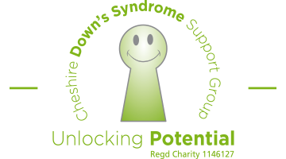
WORLD DOWN SYNDROME DAY - LOTS OF SOCKS!
Wednesday 21st March 2018
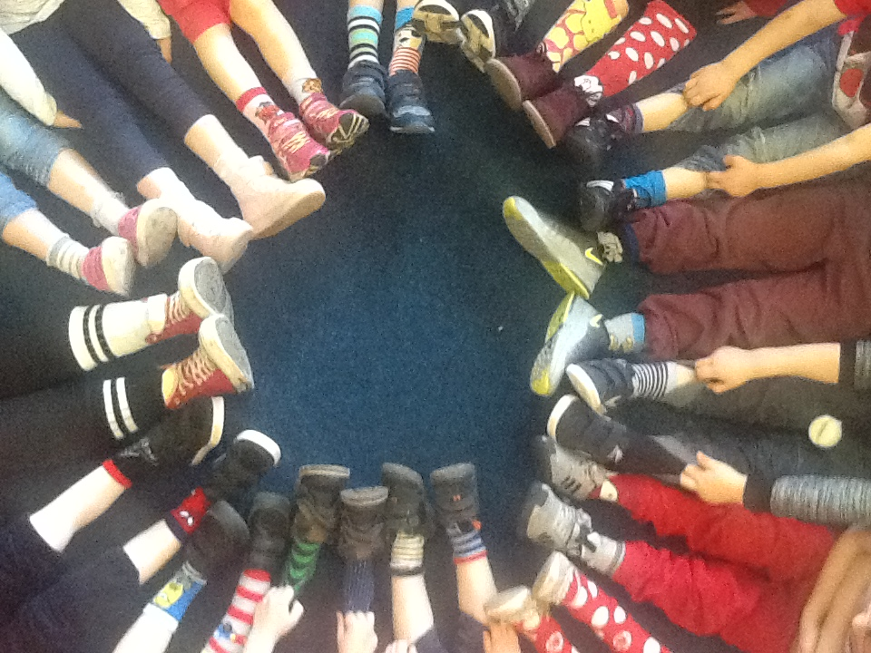
WHAT IS WORLD DOWN SYNDROME DAY?
World Down Syndrome Day is on 21st March. This date – the 21st day of the 3rd month – represents the 3 copies of chromosome 21, which is unique to people with Down syndrome. This year marks the 12th anniversary of World Down Syndrome Day, which is officially recognized by the United Nations.

This year we would like to support the Cheshire Down’s Syndrome support group by raising awareness by wearing odd socks with school uniform on Wednesday 21st March.
There is no cost for this event.

