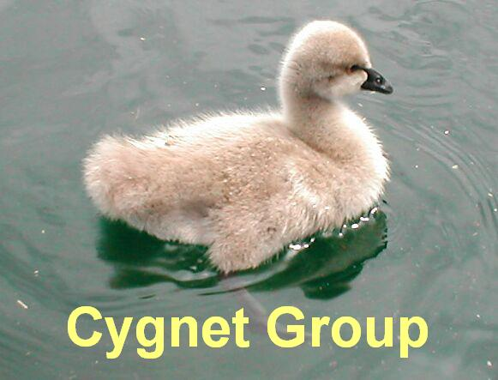

Cygnet is a parenting support programme developed for parents and carers of children/young people aged 8-16 years who have a diagnosis of an Autistic Spectrum Condition.
Parents have a lot of involvement with professionals up to and around the time of diagnosis, however they can feel that there is little available to them after diagnosis – at a time when they have a lot of questions about their child and what can help them.
Attending the Cygnet group gives parents and carers an opportunity to better understand Autistic Spectrum Conditions. It offers practical strategies that you can implement at home, gives you a chance to meet with others in a similar position and hear about their experiences.
A seven session parent training package has been developed for parents/carers whose children have been diagnosed with an Autistic Spectrum Condition.
The training is presented quite informally. The materials are flexible and can be altered to suit the needs of particular groups of parents and carers.
I would like to come, what do I do now?
Please drop in to one of our Recruitment days to complete a Cygnet Group Enrolment Form at one of our Parenting Recruitment days.
These will be held on:
Wednesday 30th January for groups running from 6th March – 1st May 2019 at Ancora House, Countess of Chester Hospital site
The Parent Recruitment times are :
8:30m - 12:30pm at Marsden House, Brookdale Place, Chester
1:30pm – 5pm at Stanney Lane Clinic, Ellesmere Port.
Tuesday 26th March for group running June – July 2019 Venue to be arranged
The Parent Recruitment times are:
8:30m - 12:15pm at Stanney Lane Clinic, Ellesmere Port
2pm – 5:30pm at Marsden House, Brookdale Place, Chester
More dates are to be arranged.

